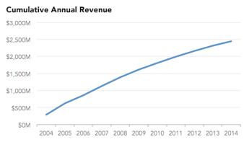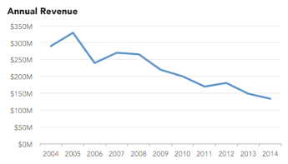

Source of the visualization:

<https://www.mapbusinessonline.com/Whitepaper.aspx/Avoid-Data-Visualization-Misinformation>

The Intended audience are the customers of this particular company and the investors, company uses misleading visual to project a false image of its financial health, to paint a rosy picture of the company's financial condition in order to meet established performance expectations

Looks nice, right? Seems like the company is doing incredibly well with the sales growing from 2004-2014. But the thing is, cumulative graph will always show an upward trend. Hence, it looks like this graph is hiding relevant information by projecting misleading information.

An alternative line plot using the real sales shows that the sales are decreasing. Now things are a lot clearer. Revenues have been declining for the past ten years! If we scrutinize the cumulative graph, it’s possible to tell that the slope is decreasing as time goes on, indicating shrinking revenue. However, it’s not immediately obvious, and the graph is incredibly misleading.